# CS 255 System Design Document Template

## UML Diagrams

### UML Use Case Diagram

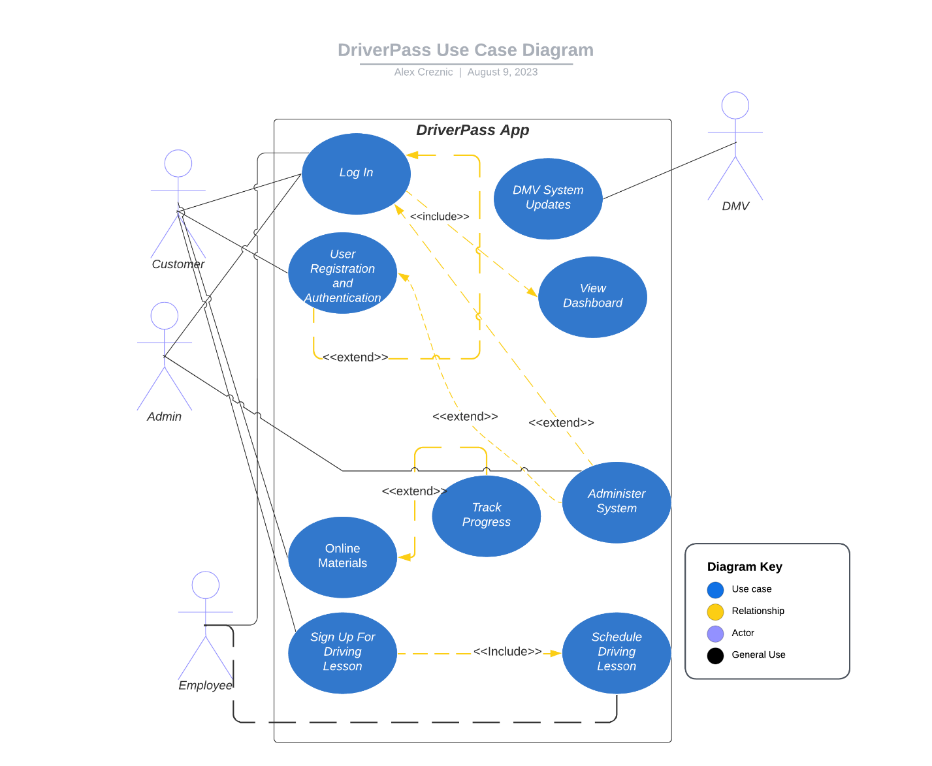

### UML Activity Diagrams

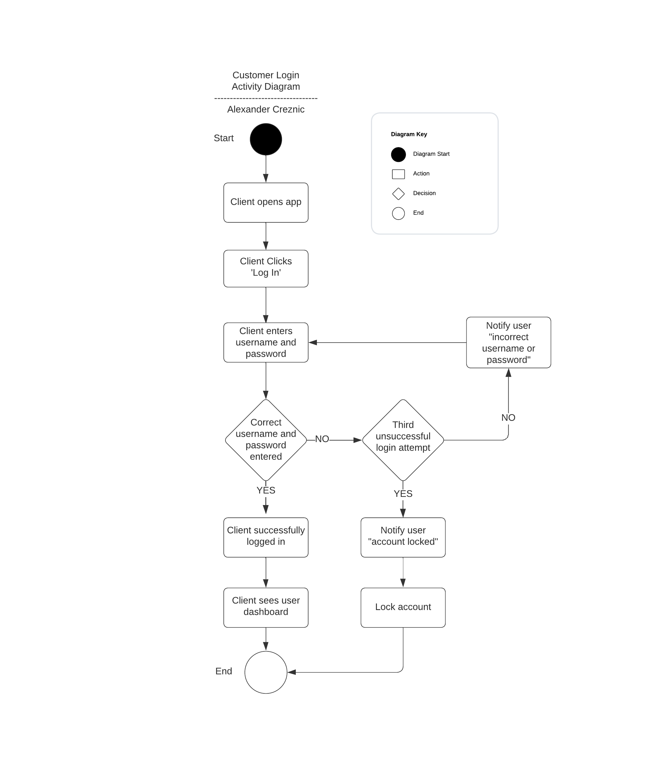

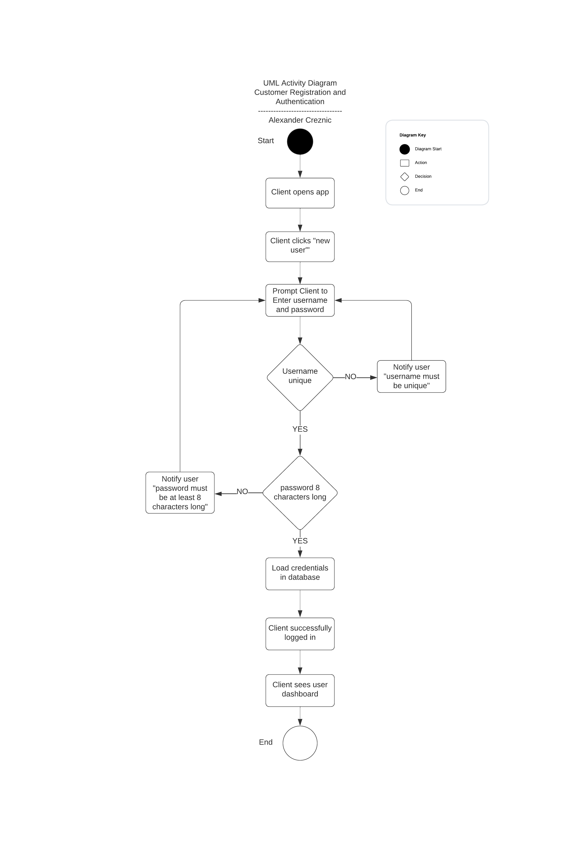

### UML Sequence Diagram

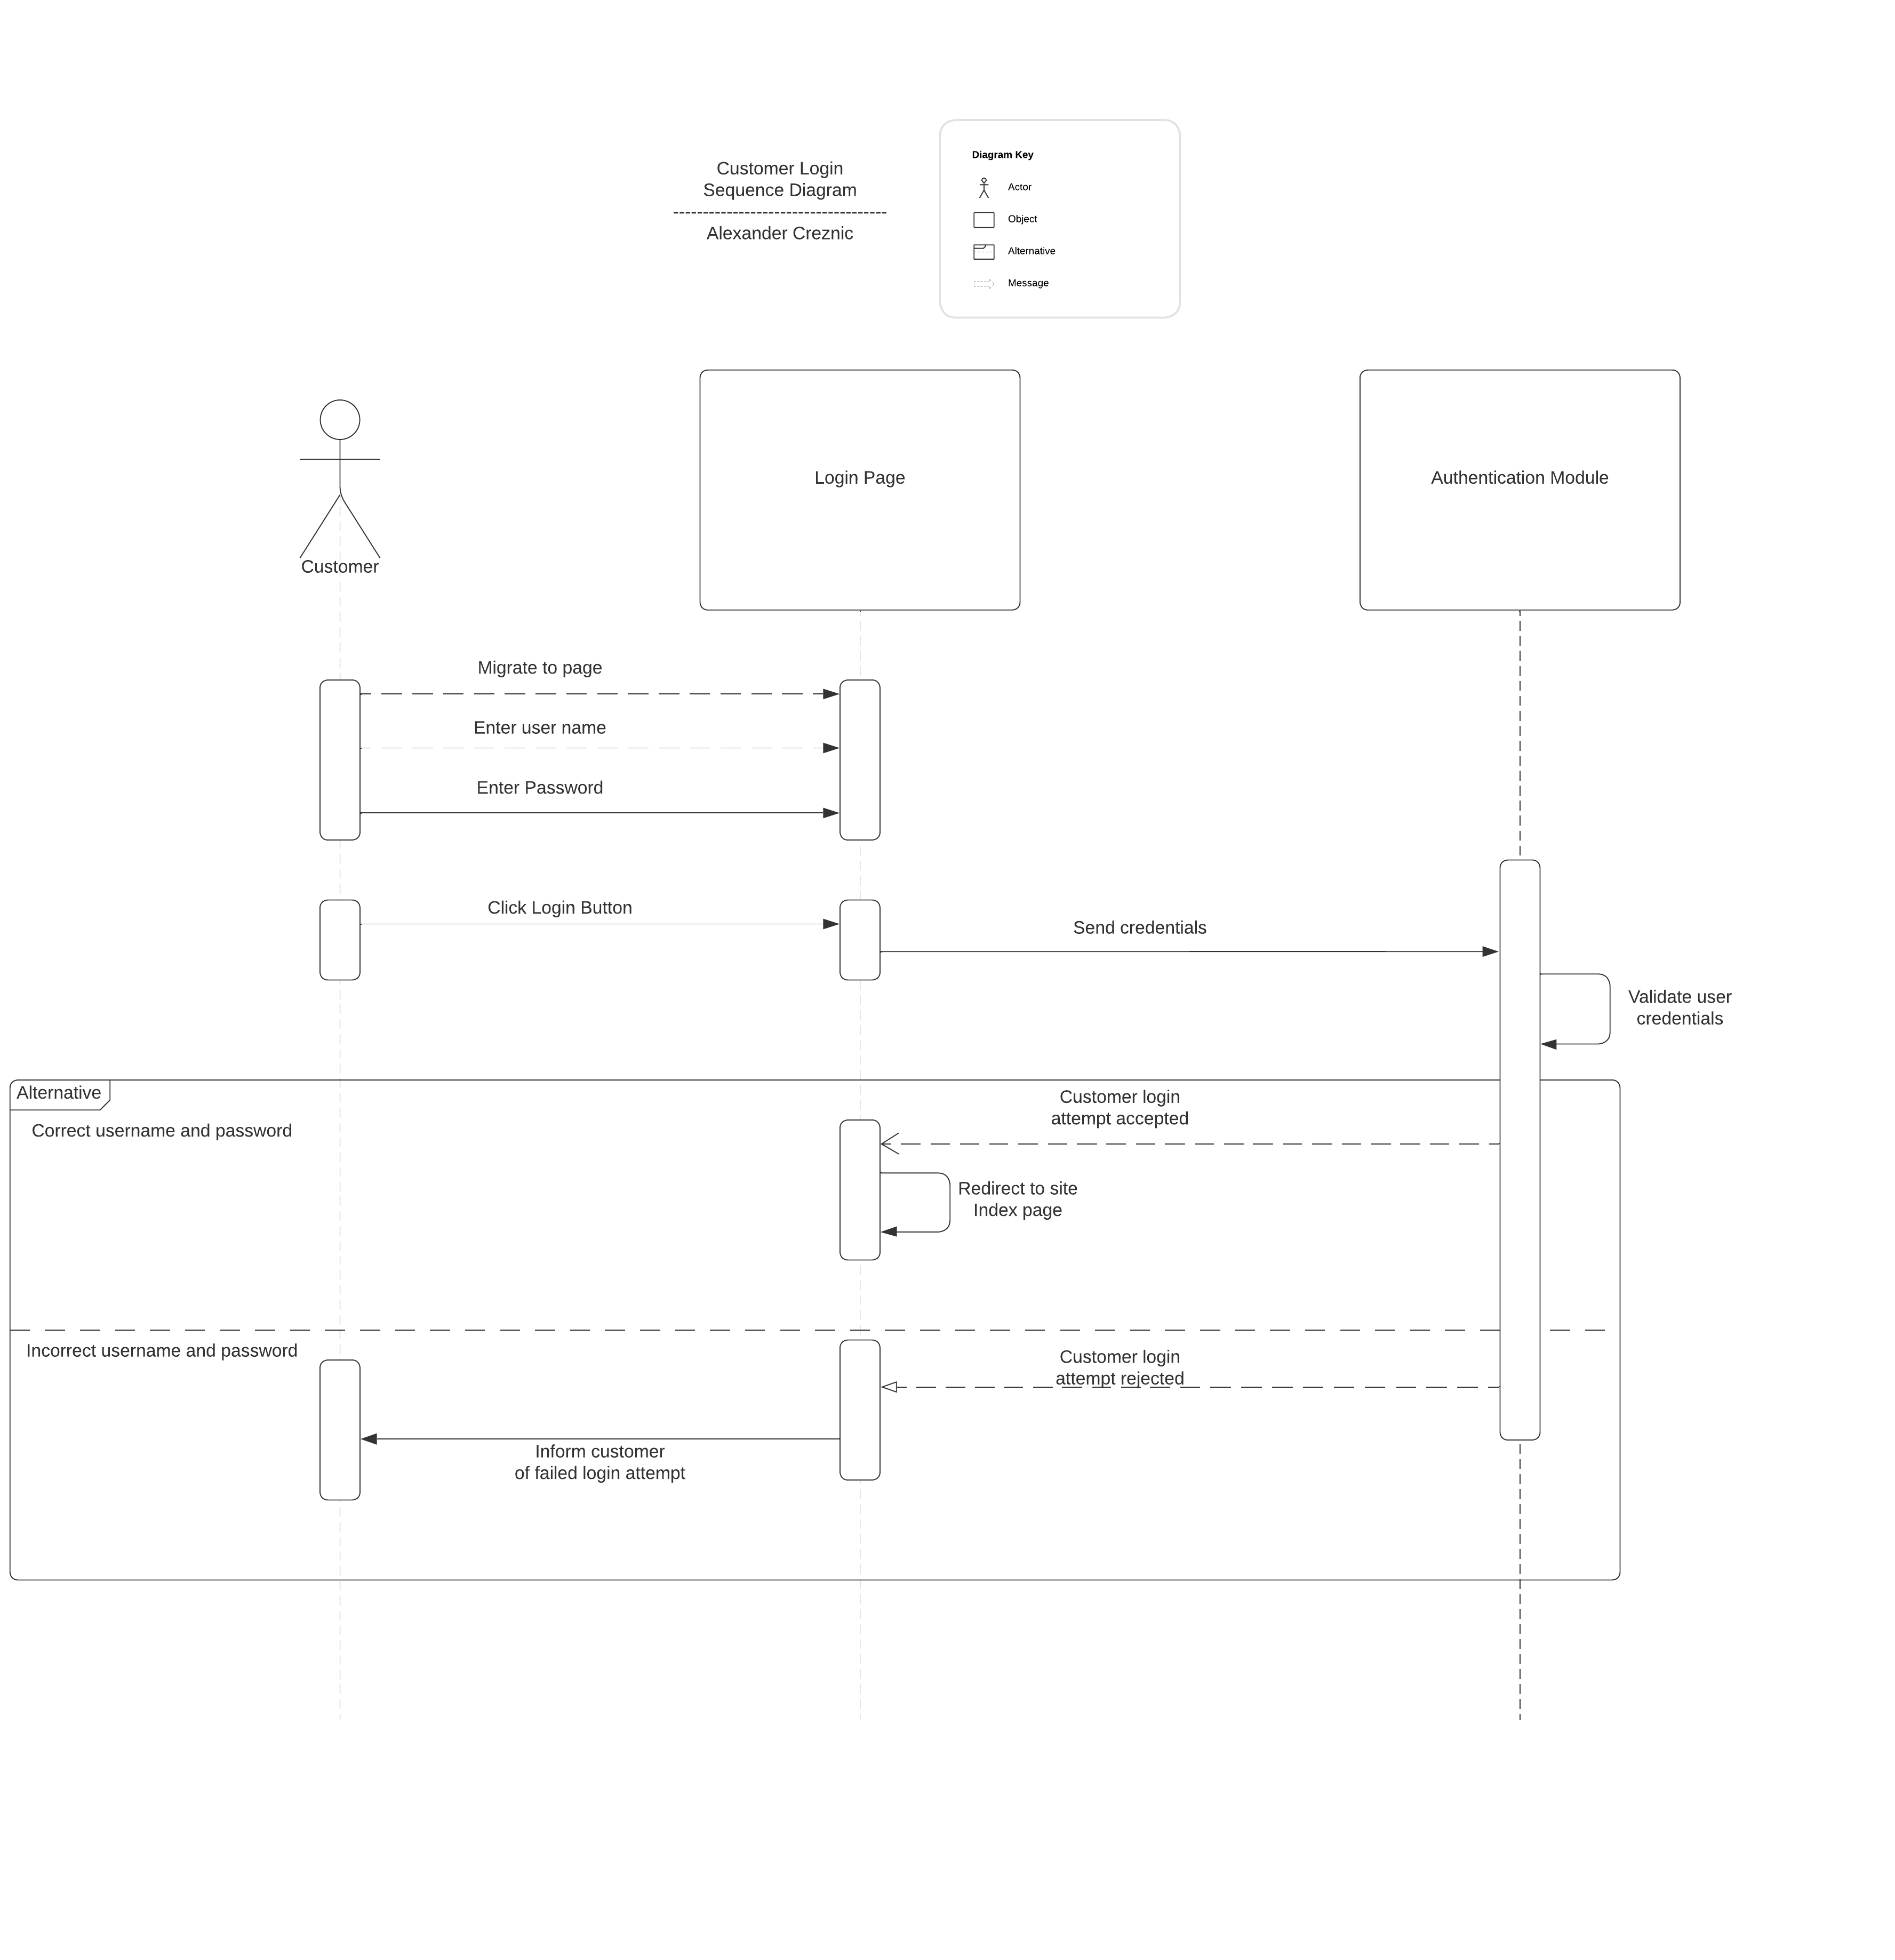

### UML Class Diagram

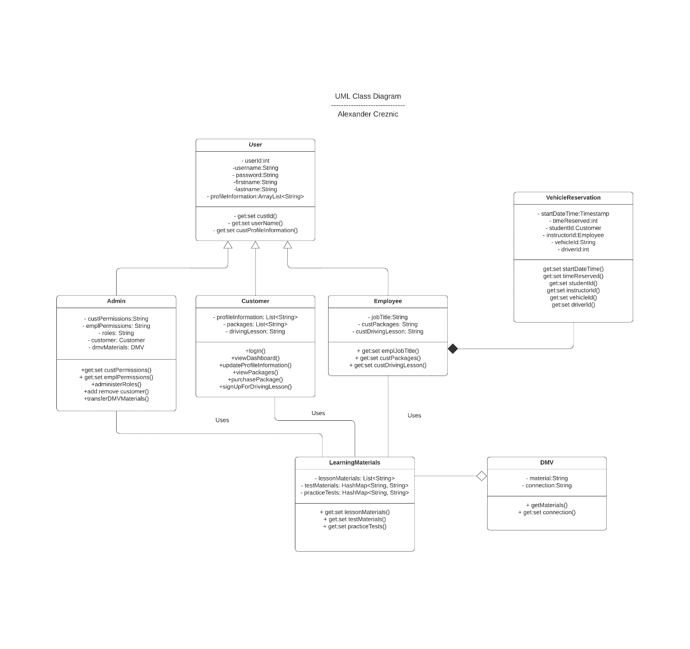

## Technical Requirements

Technical requirements for the DriverPass system are:

1. Linux web server for hosting; similar to offerings LiquidWeb or SiteGround
   1. Included:
      1. 99.99% site uptime
      2. 24/7 phone and/or email support
      3. TLS 1.3 connection encryption
      4. Security protections
      5. Scalable client/server topology
2. RESTful API integration with cloud offerings
3. Symmetric encryption for data transfer (AES), asymmetric encryption for data storage and small file transfer (RSA).
4. Pages shall be tested to be optimized for the latest iPhone and Android operating systems as of the time of writing.
5. Pages shall be tested to be compliant with the latest Chrome, Firefox, Safari, Edge, and Brave browser versions as of the time of writing.
6. Pages shall be tested for all form factors (cellphone, tablet, desktop) to guarantee easy and familiar experience regardless of access device.
7. Pages shall offer a Progressive Web App (PWA) for users who access the application from a Linux-based mobile device.
8. All data transfers shall be compressed to facilitate speed requirements and minimized downtime.